Which TFBS is what:

NFY1 → NFY-a
NFY2 → NFY-b
NFY3 → NFY-c
http://www.genecards.org/cgi-bin/carddisp.pl?gene=NFYA
trimeric CCAAT-binding TF

NFY deletion in mouse neurons in the embryo gives neurodegeneration → (think about what John said about immune genes and motility/neuronal genes perhaps having a lot in common)

Based on our findings, we propose a general model wherein NF-Y facilitates enhanced
chromatin accessibility via two modes. First, NF-Y’s nucleosome-like properties provide for
a stable and a stronger binding of pioneer factors Oct4/Sox2. Second, NF-Y’s unique DNA-binding mode, which induces ~80° bend in the DNA, imposes sufficient spatial constraints
to induce local nucleosome repositioning (such as flanking nucleosomes sliding down), thus
allowing and/or promoting binding of other TFs, whose recognition sequences become more
accessible (Figure 7F).

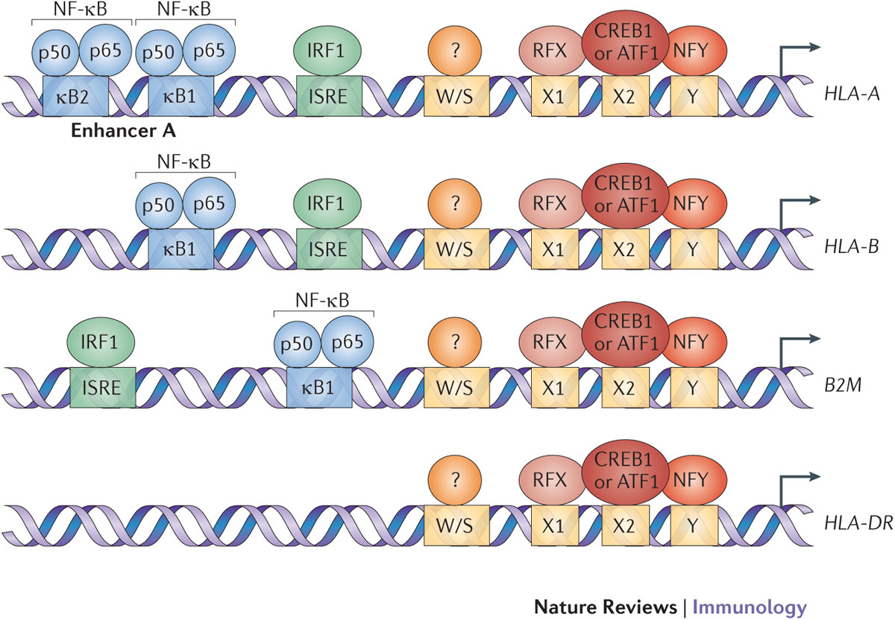

Hier → NF-Y gewoon een algemene transcriptiefactor die in MHC-1 en MHC-2 genen zit (Oldfield et al., 2014; Westerheide et al., 2001)
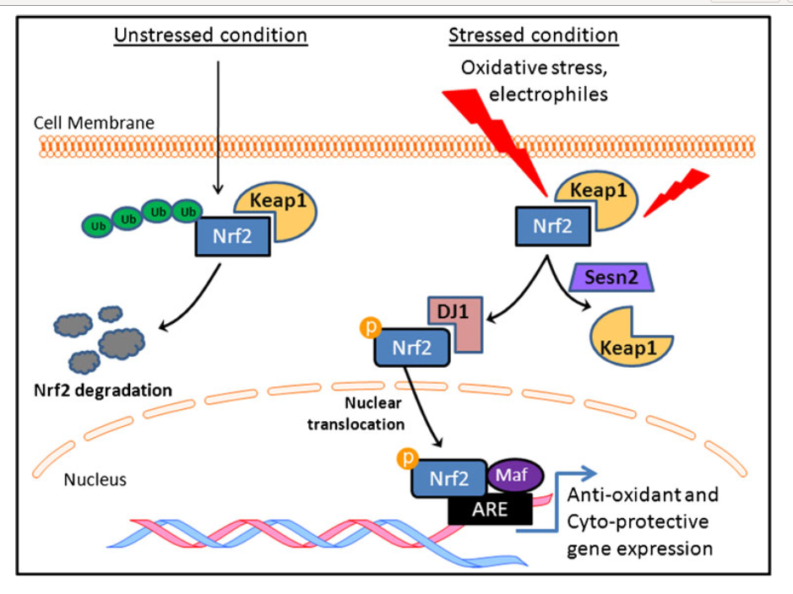
Nrf2-3 = NFE2L2 → grand regulator of cellular response to oxidative stress. Also a critical regulator of the innate immune response in infection, possibly unrelated to its role as a relay of oxidative stress (as it directly inhibits RNA PolII binding to certain target genes. (Gupte, Lyon, & Hsueh, 2013; Kobayashi et al., 2016; N. Nagai et al., 2009; Thimmulappa et al., 2006)⁠Note: TCF11 = NFE2L1. Dus deze jongens zijn hier mogelijk belangrijk? ⁠

Irf11 → only found in teleost fish, so why are these identified as evolutionary conserved TFBS?
(Huang, Qi, Xu, & Nie, 2010)⁠

Irf7 → Invaluable in the innate antiviral response, deletion mutants. Essential for induction of IFN-alpha and IFN-beta in both the MyD88- (peripheral Dcs sensing viral particulates) and MyD88-independent pathway (sensing of virus in the cell).(Vasquez et al., 2005)

Nf_kappaB2 → https://en.wikipedia.org/wiki/NFKB2 family of transcription factors important in the cellular response to stress and in inflammation, adaptive and native immunity. Also heavily implicated in cancer and auto-inflammatory diseases.(Gilmore, 2006; Perkins, 2007)⁠
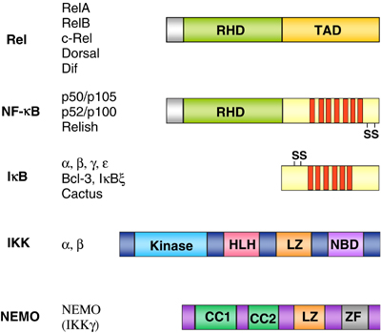
TCF11:MafG → heterodimer of a small Maf and TCF11/NFE2L1 (Husberg, Murphy, Bjørgo, Kalland, & Kolstø, 2003; Katsuoka & Yamamoto, 2016; Kim, Han, & Chan, 2016; Kurokawa et al., 2009; Kusunoki et al., 2002; Min Kim, Woo Han, & Chan, 2016; T. Nagai et al., 1998; Steffen, Seeger, Koch, & Krü Ger, 2010)⁠

